1. Case Script example

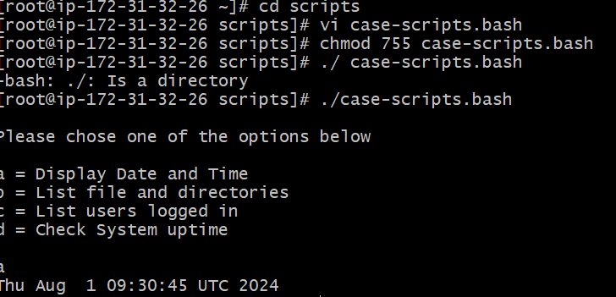

1. do-while Script

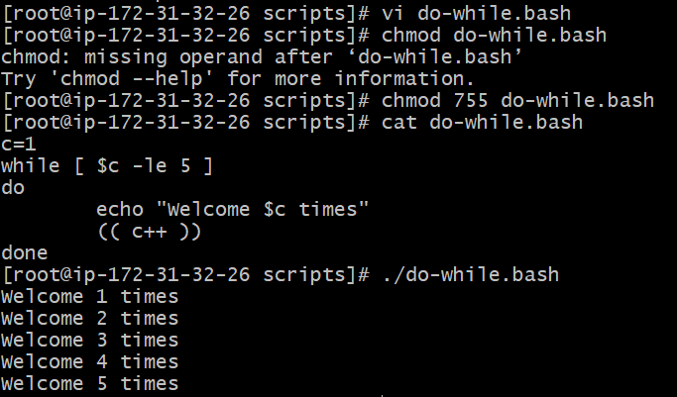

2 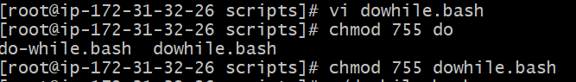

1. forloop cases

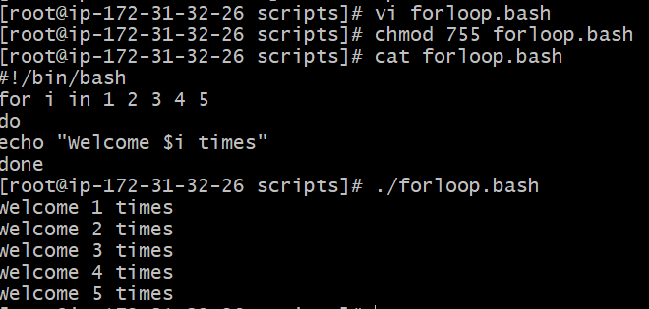

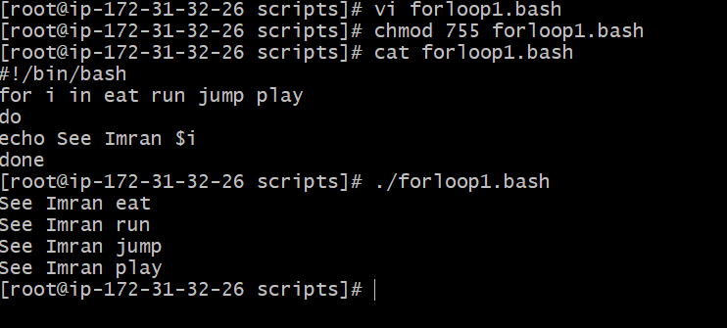

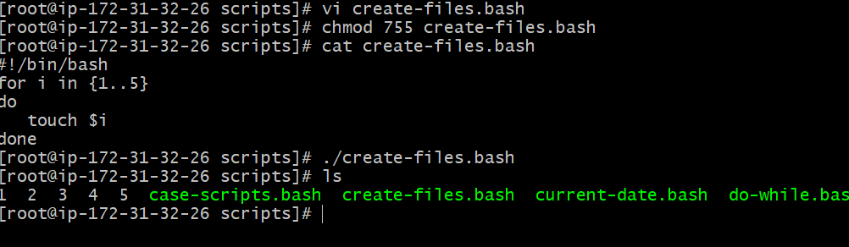

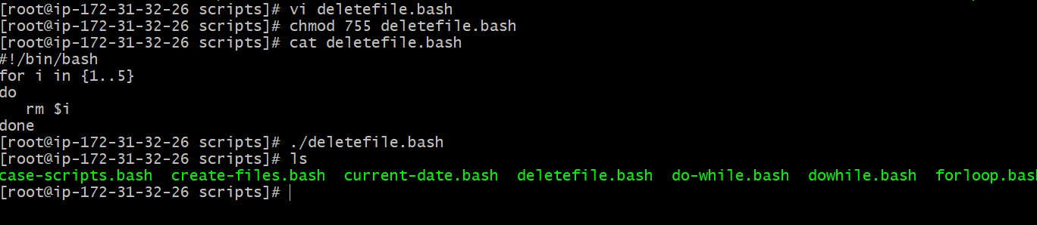

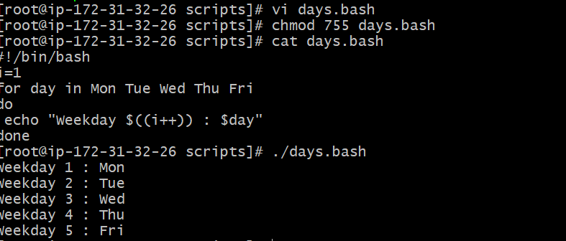

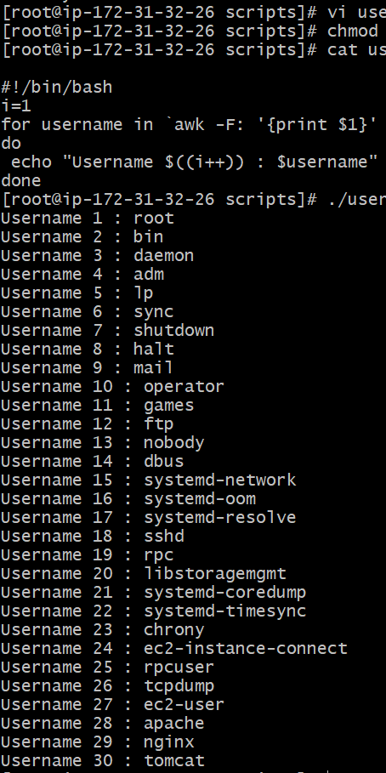

1. If-then Scripts:

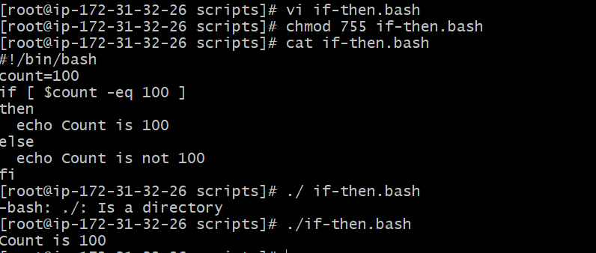

Check the response and then output



